**Tutorial 2: Templates & Data**

The data property allows us the ability to create values that are dynamically changeable.

Make sure **Tutorial 1** is complete to be able to move on to this tutorial or clone the [vue3-firebase-course](https://github.com/younggrasshopperza/vue3-basic-course) repository and go to branch called **Tutorial-1**.

**Step 1:** Continuing from Tutorial 1, in the **app.js** file create a **data function** inside your **component** that **returns a data object**. Create a data property name and assign a value.

Look at example below (**Line 3 to 8**).

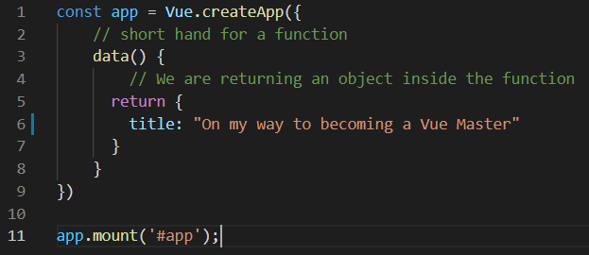

**Step 2:** Add the data property to the index.html where the Vue App is mounted.

We cannot use variables outside of the scope of the Vue App.

Look at example below (**Line 17**).

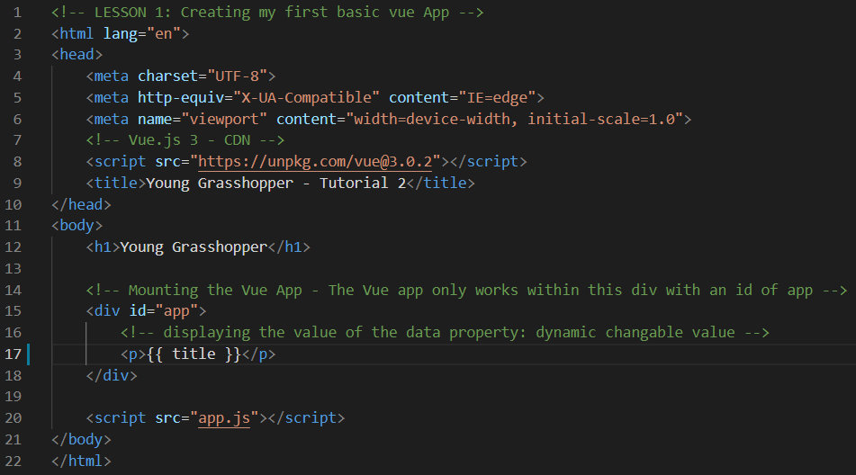

**Output**:

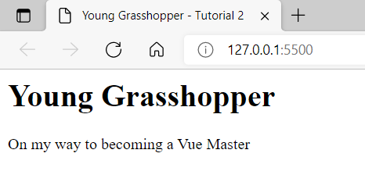

**Step 3:** Create multiple **data properties** in the **app.js** file and, add them to the **index.html** to output the values.

Look at **app.js** in the example below (**Line 3 to 11**).

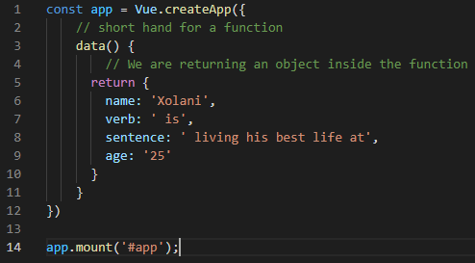

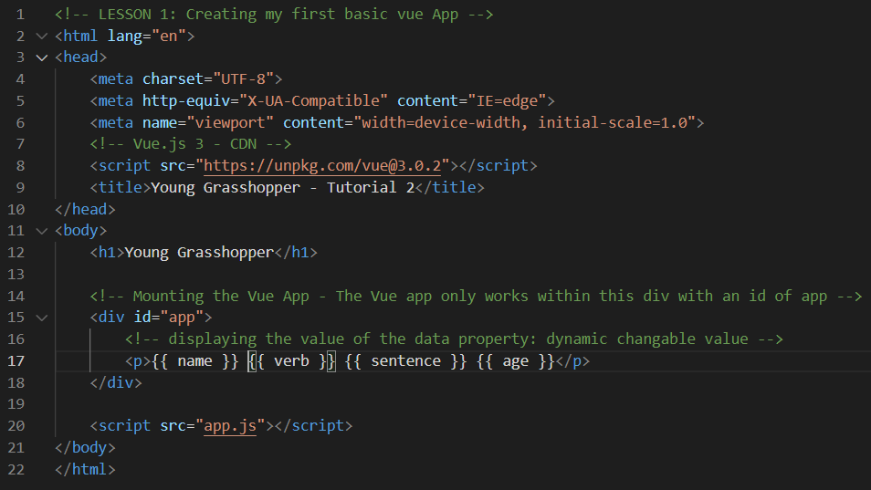Look at **index.html** in the example below (**Line 17**).

**Output:**

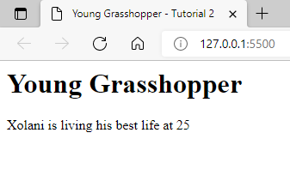

**You can view the code snippets from the** [**vue3-firebase-course**](https://github.com/younggrasshopperza/vue3-firebase-course) **repository under the Tutorial-2 branch.**